Table 3.8 in Shavelson & Webb

|  |  |  |  |  |  |  |
| --- | --- | --- | --- | --- | --- | --- |
|  |  |  |  | **Item** |  |  |
| **Person** | **Occasion** | ***1*** | ***2*** | ***3*** | ***4*** | ***5*** |
| 1 | 1 | 5 | 5 | 4 | 4 | 3 |
|  | 2 | 5 | 5 | 4 | 4 | 4 |
|  |  |  |  |  |  |  |
| 2 | 1 | 3 | 4 | 2 | 3 | 2 |
|  | 2 | 5 | 5 | 2 | 2 | 4 |
|  |  |  |  |  |  |  |
| 3 | 1 | 1 | 4 | 5 | 2 | 4 |
|  | 2 | 2 | 3 | 5 | 2 | 3 |
|  |  |  |  |  |  |  |
| 4 | 1 | 3 | 3 | 2 | 2 | 4 |
|  | 2 | 4 | 4 | 2 | 2 | 2 |
|  |  |  |  |  |  |  |
| 5 | 1 | 1 | 4 | 4 | 2 | 2 |
|  | 2 | 2 | 4 | 4 | 3 | 5 |
|  |  |  |  |  |  |  |
| 6 | 1 | 2 | 2 | 2 | 1 | 2 |
|  | 2 | 1 | 3 | 1 | 1 | 2 |

Re-formatted

|  |  |  |  |  |  |  |  |  |  |  |
| --- | --- | --- | --- | --- | --- | --- | --- | --- | --- | --- |
|  |  |  | **O1** |  |  |  |  | **O2** |  |  |
| **Person** | ***I1*** | ***I2*** | ***I3*** | ***I4*** | ***I5*** | ***I1*** | ***I2*** | ***I3*** | ***I4*** | ***I5*** |
| 1 | 5 | 5 | 4 | 4 | 3 | 5 | 5 | 4 | 4 | 4 |
| 2 | 3 | 4 | 2 | 3 | 2 | 5 | 5 | 2 | 2 | 4 |
| 3 | 1 | 4 | 5 | 2 | 4 | 2 | 3 | 5 | 2 | 3 |
| 4 | 3 | 3 | 2 | 2 | 4 | 4 | 4 | 2 | 2 | 2 |
| 5 | 1 | 4 | 4 | 2 | 2 | 2 | 4 | 4 | 3 | 5 |
| 6 | 2 | 2 | 2 | 1 | 2 | 1 | 3 | 1 | 1 | 2 |

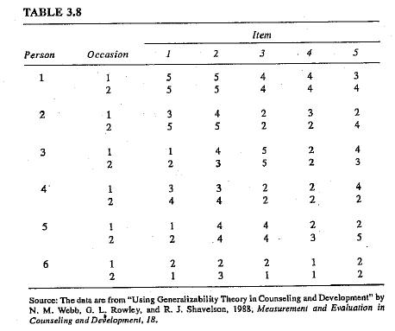

You will need to use the same data file of p x o x i design from Shavelson and Webb chapter for multiple mini-projects. For mini-project 2, you will practice the coding for a 2-facted model. Then in mini-projects 3 and 4, you will perform different types of D-studies to understand the nested design and fixed facet.

**Mini-project 2**

In this project, you will need to perform the G and D studies for multi-faceted design. The overarching questions are:

* What are the main sources for the measurement errors?
* What alternative measurement procedure will you recommend if we aim for an absolute G coefficient as .75?

**Mini-project 3**

In your decision studies, please consider two designs: p x (i : o) and i : o : p.

For both designs, use o =2 and i=5.

Once you have the output, compare the results against the d study of p x o x i when o =2 and i=5. What do you notice about the estimated variance component s (EVCs)?

Then without running a genova program, can you figure out the EVCs for a design of (i : p) x o? Again o =2 and i=5.

**Mini-project 4**

Now we are going to explore the fixed facet. This has several sub-tasks.

a) In your 1st decision study, treat the item facet as fixed. Remember that in the effect line, 0 indicates infinite. So you need to change the 0 as 5 (see below).

EFFECT + I 5 5

Read the output and see what happens to EVCs. Any patterns do you notice when comparing to the p x o x i output of EVCs?

b) Run two additional D studies where o as a random facet (using two occasions) and i as a fixed facet. In your 2nd d study, we consider using only 3 items (but taking from the five items we treat as fixed). In your 3rd d study, use 2 items which again should be randomly taken from the five items.

Read the output and see what happens to EVCs. Any patterns do you notice when comparing to the p x o x i output of EVCs?